**CS5551 Lab Assignment – 2 Report**

In this Lab Assignment -2, I have created an application that helps the user in finding way to the Great Smoky Mountains and also displays the user with its weather conditions at any moment of time. I have used Google Maps web services and Yahoo weather web services for this application. I have created the application by making use of HTML, CSS, Javascript and JQuery Mobile.

In this application, the user has a choice to select the Directions for Smoky Mountains from their current location (Kansas City, MO) or also the Weather at smoky mountains. The Screenshots of the above mentioned application are presented below.

Also, as advised I have used Opera Mobile Emulator for seeing the application in a mobile interface and the screenshots of the Opera Mobile emulator are also presented below.

**Jsfiddle.net Link:** <http://jsfiddle.net/eCL5Q/>

**Screenshots from Jsfiddle.net:**

1. The user is at the Home page by default and he can come back at any point of time to this page by clicking the “Home” button at the top left of every page.

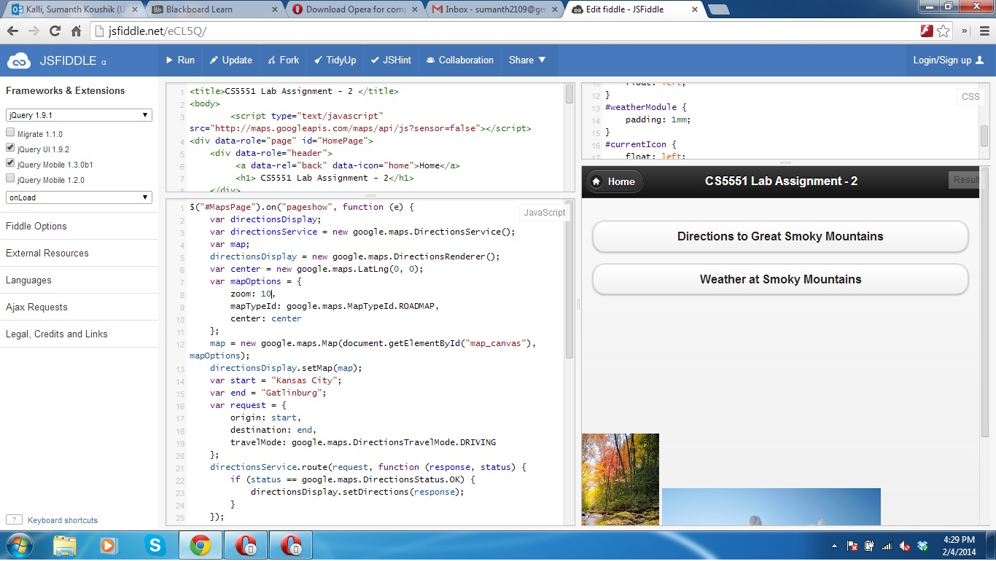

1. The user has the option to click for Directions on the “Directions to Smoky Mountains” and he gets the driving directions.

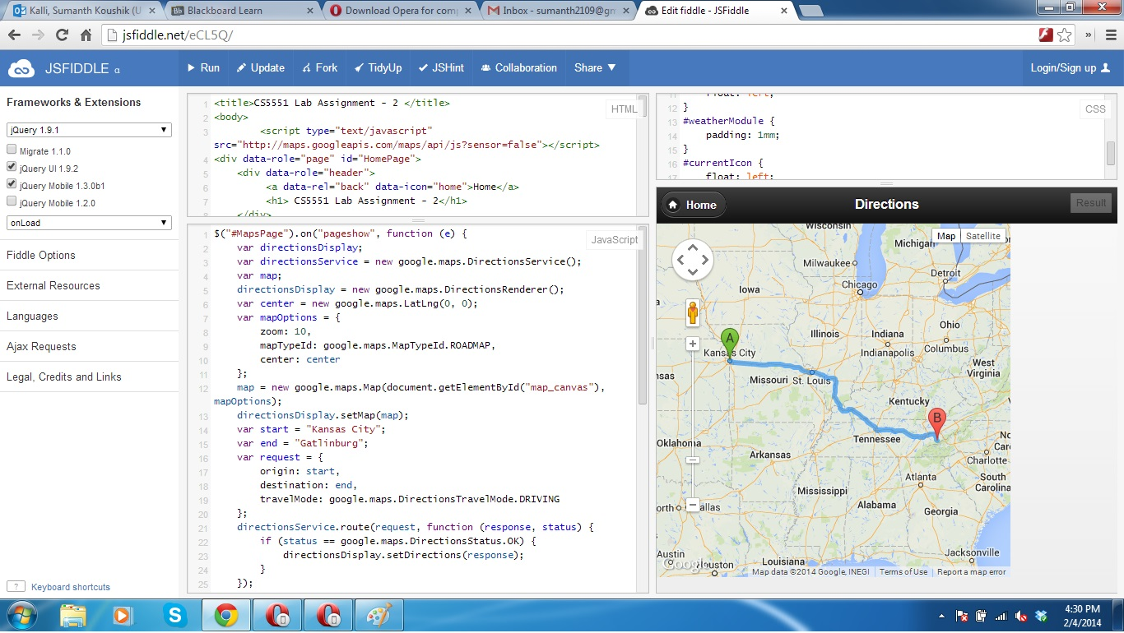

1. The user then has the choice to see the weather conditions at Smoky mountains by clicking the “Weather at Smoky Mountains”

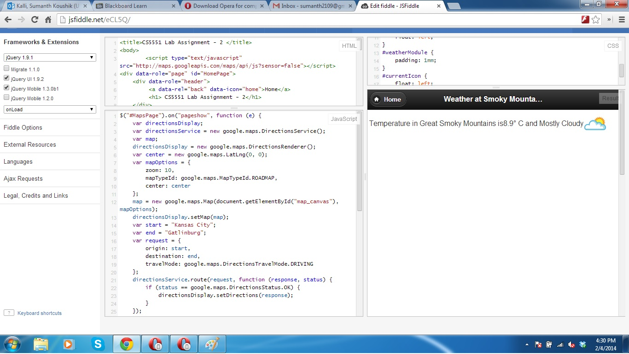

**Opera Mobile Emulator Screenshots:**

